YEAR 7 SCIENCE
CHEMICAL SCIENCES
PRACTICAL - SEPARATING SOLUTIONS

Aim: To investigate how to separate a solution into the solute and solvent.

Method:

Part A - Evaporation

• Set up the following apparatus.
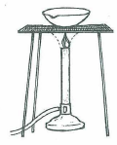

• Place 20 mL of copper sulphate solution into the evaporating basin.
• Set the Bunsen flame to the coolest blue flame with the slightest hint of yellow at the top.
• Heat the solution gently by moving the Bunsen in and out from under the basin.
DON'T ALLOW IT TO BOIL!
• Observe carefully what happens.

Part B - Distillation

• Set up the following apparatus

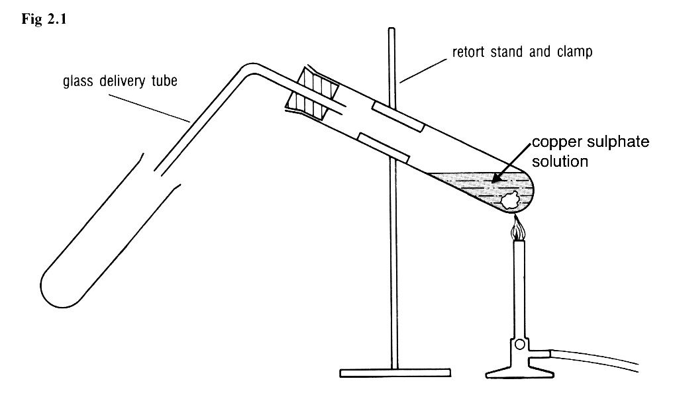

• Set the Bunsen flame to the coolest blue flame with the slightest hint of yellow at the top.
• Heat the solution gently by moving the Bunsen in and out from under the test tube.
DON'T ALLOW IT TO BOIL!
• Observe carefully what happens.

Observations

Part A:

Part B:

Discussion:

• What is the true colour of solid copper sulphate?

• Research on the Internet to find out why the copper sulphate solid you used in making the solution is blue.

Conclusion:

